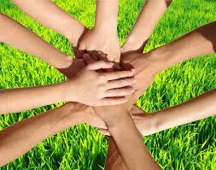
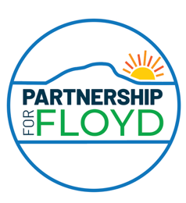
2025 Floyd Get to Know
Your Neighbors Campaign
Sponsored by Partnership for Floyd
After recent disasters, it is clear that getting to know our neighbors is important, especially in a rural community where some services may be unavailable.
Good neighbors may be our best hope in an emergency.
Good relationships are an everyday key to a
Happy, Safe, Resilient Floyd community.

To our neighbors ___________________________________________________

From your neighbors:

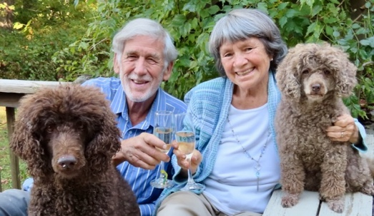
Who live at
SAMPLE photo
____________________________________________

We hope you can join us for a casual neighbors’ potluck gathering!
on ___________________________
at _______________________________________________

We are hosting a private Facebook page to share neighborhood information at

____________________________________________________________________________

